# Financial Timeseries Data — Import Pandas

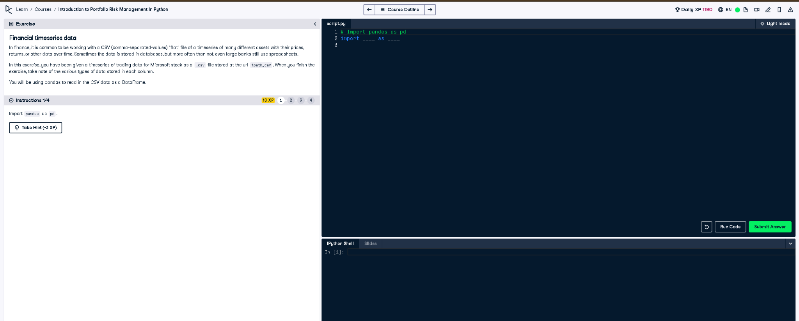

## ✅ Full Correct Answer:

# Import pandas as pd  
import pandas as pd

## 🧾 Explanation (Simple Words):

This task simply asks you to import the pandas library and give it the alias pd. Pandas is widely used for handling tabular data such as financial time series. We use it to load and manipulate CSV files like the one mentioned in the exercise.